**Automation Test Engineer Capstone**

**Load testing using JMeter**

1. **Recording a flow on the website -**[**https://www.saucedemo.com/**](https://www.saucedemo.com/) **using Blaze meter plugin and downloading .jmx file.**

1. **Importing the .jmx file in JMeter and running the script.**

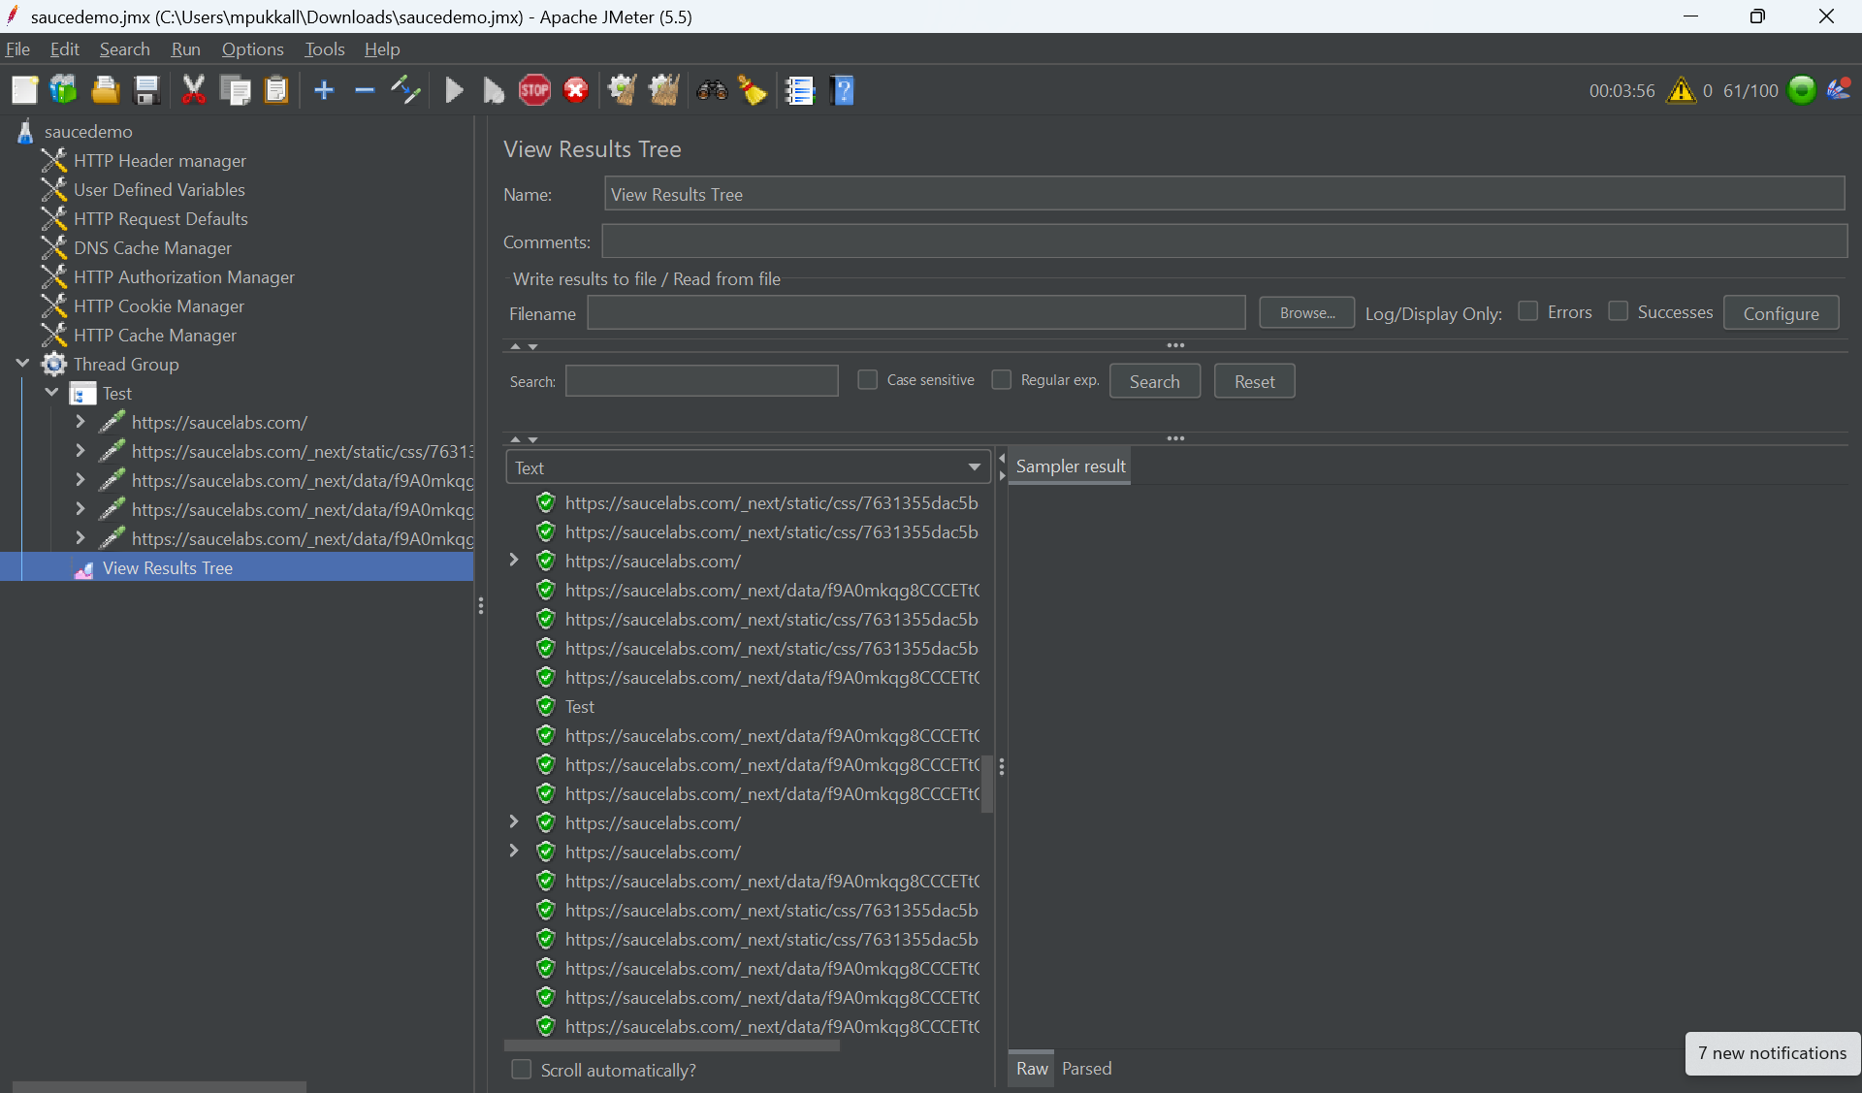

1. **Uploading the recorded script on Blazemeter cloud and running the script from 20 minutes with 50 Virtual Users**

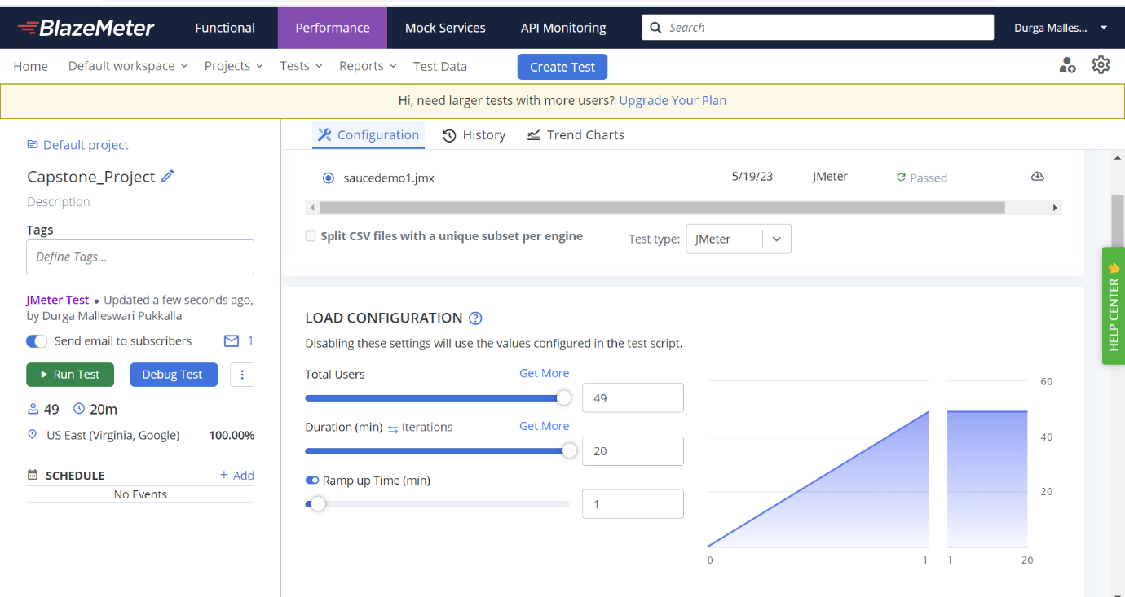

1. **Script running with the load.**

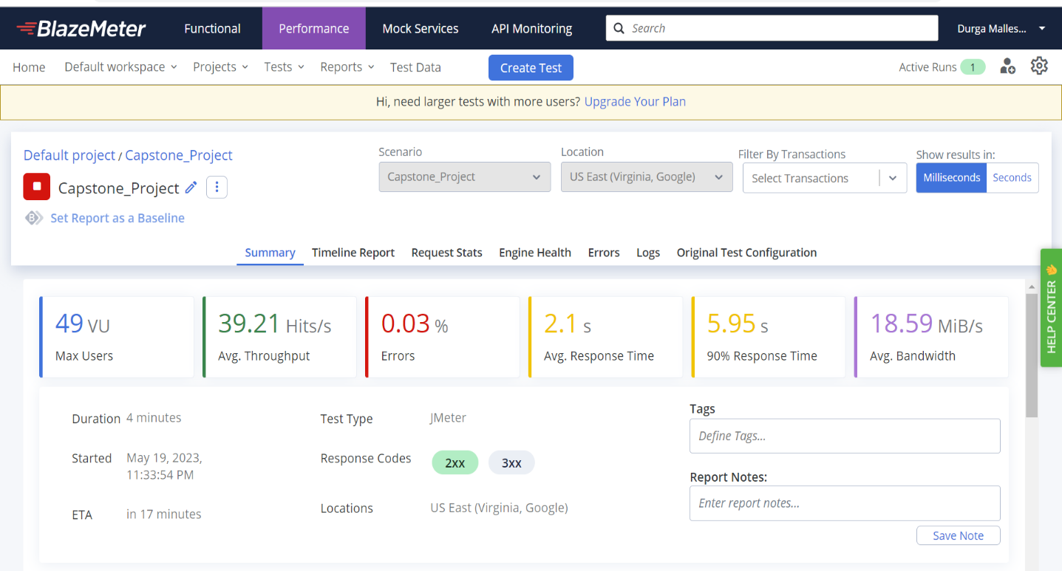

1. **Test report:**

